Vancouver island  Interclub Competition | - HELD AT  - Kerry Park  - •  - Recreation Centre
Competition update  We are on the way to being organized for the upcoming competition. Thrifty’s is one of our sponsors for goodie bags. Sponsors have also been secured for the photocopier and we are looking into a paper supplier.  Ice was booked in the spring and the Judges platform is being worked on by the Kerry Park maintenance staff as it is always a challenge due to CVRD requirements.  Photographers are a challenge as it is the first day of Santa in the malls and also hockey tournaments. We are still looking.  Meals will be prepared by the Kerry Park Food Services staff. We are currently waiting for a quote.  We are on time and still on budget! | 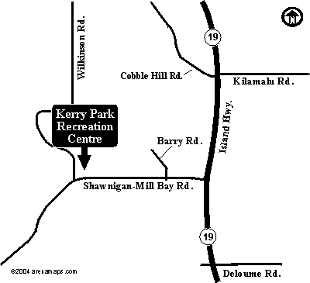  Contact Info  Betsy Burr  250 744-9269

